http://www.unisim.edu.sg/about-unisim/Overview/PublishingImages/UniSIM_logo.gif

**GSP177E**

**Fundamentals of Investing**

**Tutor-Marked Assignment 1**

**July 2016 Presentation**

Name: Lim Hui Qin

Student ID: Z1610579

# Investor Profiling

Investor Mr X is in his mid-50s, considering the average expectancy of male Singaporean, he has an estimated time horizon of twenty years to invest. Retrenched by his company, he is entering the retirement stage of lifecycle. It is advisable that he keeps an amount of liquid cash for expenses to cope with retirement. An evaluation of his financial health shows that he is debt free and has little liability. The house he lives in is fully paid and he has sufficient insurance policies to protect him and his family in case of emergencies. His wife is currently working and hence expected that she is self sufficient. Thus his current and only liability is to provide funding to sponsor his son’s university education in UK. Additionally, Mr X has a liquid funds totaling to SGD 1.3 million. If he were to set aside SGD 300,000, he would be left with SGD 1 million for investment. Hence I would conclude that he is financially healthy with low liquidity needs. It is given in the case study that he has prior investment experiences. Considering his financial stability, liability and current stage of lifecycle, I would assume his level of risk tolerance to be moderate. He has a potential for high level of risk tolerance as he is financially stable with liquid funds and investment experiences. However, in retirement stage, it would be difficult for him to seek employment that maintains his level of income if he were to re-enter the workforce. His profile matches that of a moderate investor whose main objective of his investment is to preserve capital while gaining returns to cover living expenses and his son’s cost of education.

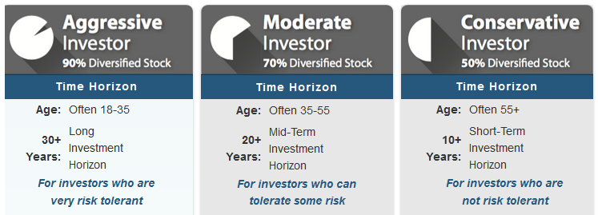

# Proposal Analysis

The proposal by Ms Angeline is an example of Real Estate Investment Trusts (REITS) whereby it allows Mr X to engage in short term investment of heritage buildings in Germany with a return of 24% over a period of two years. Investing with AHPL provides Mr X access to professionals who are experienced in real estate investments. Payment of dividends is regular, with annual payouts over the investment period and currency exchange rates will not affect the returns as AHPL pays investor in SGD. However, Mr X will not have control over investment properties and management decisions, such as acquisitions and disposals of properties. Another disadvantage of REITS is the constant call for capital increase and the impact it has on ownership dilution. In such scenario, the distribution of dividend earnings amongst investors will be impacted. The underlying risk in Ms Angeline’s proposal is the book value and potential for capital appreciation with this product. REITS is impacted by changes in real estate market and the country’s state of economy. Although investors are not direct buyers or owners, they are still affected by market prices of properties.

The proposal by Mr Billy is an instance of mutual funds, where ENBL obtain a pool of funds from investors like Mr X to invest in a portfolio of various investments products such as equities and fixed income securities. Similarly, investing with ENBL opens Mr X to a pool of professionals who are experienced in portfolio management and evaluation of investments merits. This would certainly save Mr X the trouble of having to do intensive research on his own. The investment portfolio suggested by Mr Billy is diversified across stocks, bonds and currencies. This will greatly reduce the risk and market volatility associated with the asset classes for Mr X. ENBL provides high level of customizations for investors, allowing them to alter asset weightings and empowering them to override investment decisions made by management. However, management changes within ENBL with direct impact to fund managers may in turn affect the portfolio performances. Also, mutual funds trading abuse is prevalent and could harm the interests of investors. Monetary Authority of Singapore (MAS) has stringent policies on regulated trading activities governed under the Securities and Futures Act. It is necessary for ENBL to adhere to the Act.

# Investment Recommendation

I would recommend Mr X to invest in both REITS and mutual funds as proposed by Ms Angeline and Mr Billy respectively. Accepting both investment proposals is a way for Mr X to diversify his investment portfolio and further reduce the risk associated with investing. With the liquid fund of SGD 1.3 million, Mr X can consider allocating his funds as shown below:

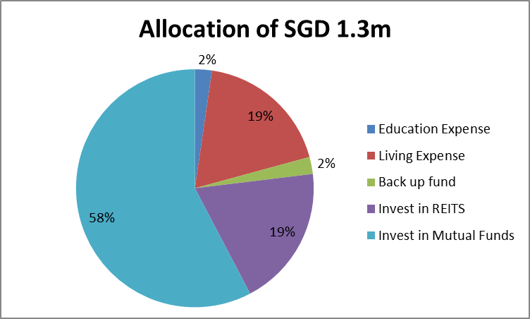

SGD 30,000 is set aside for Mr X’s son’s education and estimated amount of SGD 240,000 is set aside for his living expenses for 20 years. The separate amount of SGD 30,000 termed as back up fund is not used for investment purposes nor factored in as expenses. The back up fund is for Mr X to use in the future in unexpected situations such as coping with inflation, economy downfall and re-financing his investments. As a retiree without extra income other than investment returns, it is a conservative approach to have back up funds in case of rainy days.

Mr X can consider investing SGD 250, 000 with AHPL in REITS. As it is a short term investment over a period of two years, the risk involved in relatively low. In addition, investors’ rights are protected by Lloyd’s insurance and the company is duly registered with CEA. This gives investors the assurance to place their funds with AHPL. With annual returns payout and the capital amount returned on the second year, Mr X can expect to have his capital preserved with slight earnings at the end of the investments period. This investment strategy is aligned for a moderate investor like Mr X who can tolerate risk and expect average returns.

Investing SGD 750 000 in mutual funds with ENBL may appear as unbalanced compared to AHPL, however ENBL provides more liquidity. Mr X does not have to wait for a long period as he can expect to receive returns each time he redeems his shares or units. However, I am proposing to adjust the current asset class to reduce the weightings for stocks. The new asset class serves to reduce the risk associated with stocks while placing more emphasis on bonds. Although bonds is less profitable than stocks, it is also less risky. The profile of Mr X is that of a moderate investor, having an asset class with 80% on stocks alone is a stretch for the risk tolerance as stocks market is highly volatile.

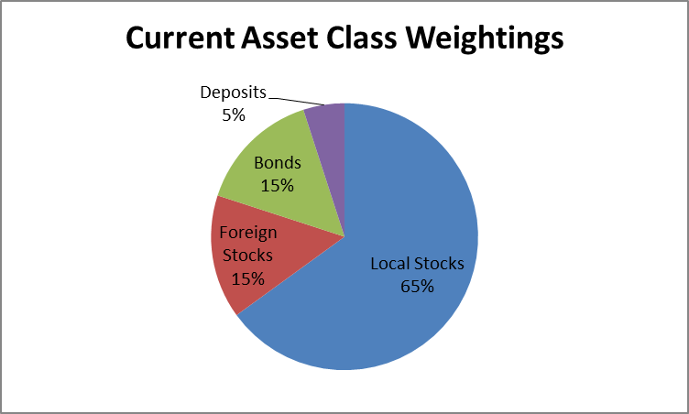 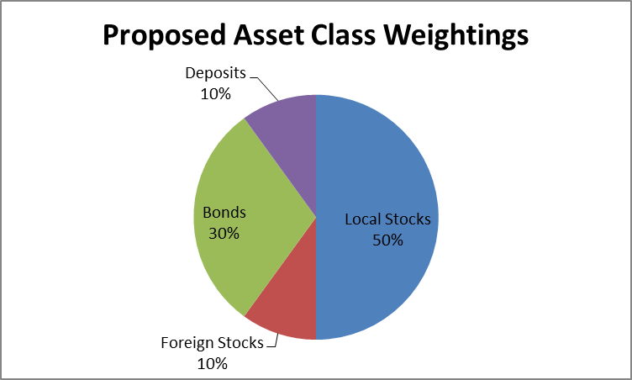

Above all, it is recommended that Mr X monitor his investments regularly and make necessary adjustments to update his portfolio as when required because investments is a risk taking activity where the certainty of returns has to be constantly evaluated.

# References

1. Department Of Statistics Singapore. (n.d.). Retrieved August 17, 2016, from *http://www.singstat.gov.sg/statistics/visualising-data/charts/life-expectancy-at-birth*
2. Regulatory and Supervisory Framework. (n.d.). Retrieved August 17, 2016, from *http://www.mas.gov.sg/Regulations-and-Financial-Stability/Regulatory-and-Supervisory-Framework.aspx*
3. What's Your Investment Strategy: Capital Preservation vs. Capital Growth - Millionaire Money Habits. (2008, July 21). Retrieved August 17, 2016, from *http://www.mmhabits.com/what’s-your-investment-strategy-capital-preservation-vs-capital-growth/*
4. AAII: The American Association of Individual Investors. (n.d.). Retrieved August 17, 2016, from   
   *http://www.aaii.com/asset-allocation*